**Project Requirement**

**Beat Me**

CS 157A - TEAM 1

Kun He, Tien Pham, Han Kang

**Sep 6, 2019**

**CS 157A - [Section 01]**

1. **Project Overview**

**1.1. Background**

* The number of e-commerce shoppers is growing every year. Often, they have a difficult time to find the best price for what they are looking for. For example, on Amazon Prime Day, because lots of products are on sale at the same time, the shopper may have a hard time to figure out which products provide the best price. Also, the cost of the product is continually changing, and the list of the item looks very similar.

**1.2 Customer or Market Needs**

* According to *Figure 1.* by Statista, the number of e-commerce shoppers in the United States is growing. Therefore, the online deal tracker would help them to find the best price for the product. Currently, there is a website called *CamelCamelCamel,* which allows the online shopper to keep track of the item price, yet it is only for Amazon. *Beat Me* keeps track of the item price over verified online retailers so that the shopper is more likely to find the best price for the specific item.

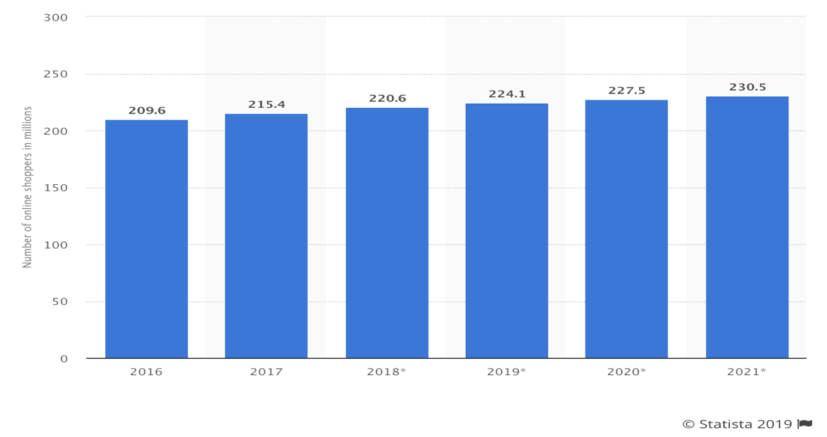

Figure 1. Number of digital shoppers in the United States from 2016 to 2021 (in millions)

**1.3 Stakeholder Profile**

**1.3.1 Clients**

* Anyone can use *Beat Me* to find the best price on the online retailer’s website. *Beat Me* will guarantee the user’s convenience because *Beat Me* will notify the user when the price cheaper than usual so that the user does not need to keep checking the price of the product.

**1.3.2 Investors**

* The small online retailer could have more benefits than big online retailers such as Amazon or eBay because Beat Me will provide advertising effects.

1. **System Environment**

**2.1 A Structure Diagram of The System**

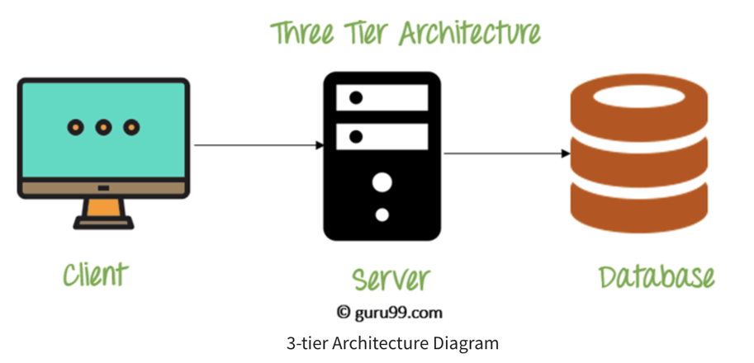

*Figure 2. 3-Tier Architecture*

**2.2 System Requirement**

* Front-end(Client): React JS, HTML, CSS, Javascript
* Back-end: Flask, Python
* Server: Apache
* Database (RDBMS - Database): MySQL 8.0
* Software: Git, Github, Taiga, Google Drive.

**REFERENCES**

 DBMS Architecture: 1-Tier, 2-Tier & 3-Tier. Retrieved from

https://www.guru99.com/dbms-architecture.html

 Number of digital shoppers in the U.S. 2021. Retrieved from

<https://www.statista.com/statistics/183755/number-of-us-internet-shoppers-since-2>

009/